I wish to apply for membership of Parley Pétanque Club and agree to abide by the rules and regulations as outlined on the club website.
Please be aware that you can visit the club three times before you decide to join. However, payment does not guarantee acceptance. Parley is a harmonious and friendly club where everyone is valued and welcomed. People who threaten to create problems including friction or disharmony are not welcome. Please see our code of conduct for more details
Please complete all sections
Name
Address & Postcode
Home Telephone
Mobile Telephone
Email address
- In making this application, the following is important. This information will be held confidentially
Do you have any significant health issues we might need to be aware of? Y / N
(if yes please give a brief explanation) ....................................................................................................
• Are you on the Children's Barred List.? Y / N
Other:
- To comply with insurance and health and safety requirements, you may only play in shoes or trainers. Sandals or flip-flops are not acceptable.
- Parley Pétanque Club exists for the pleasure of our members. No foul language, verbal or physical abuse will be tolerated at any time.
Please note:
- Days and times of play may change depending on the weather and time of year.
- You will always have access to the terrain except during competitions.
- Parley Sports and Social Club is closed now. However, membership of the Pétanque Club includes membership of the Sports Club when it opens.

- Please return this form to the membership secretary
Erica Dixon-Gough 25 Parley Close, West Parley, Ferndown, Dorset, BH22 8PH Email.ejdg59@sky.com
We encourage all members to join the National Governing Body.
This can be done online at Pétanque-England.uk
Club Membership payable to
I agree to Parley PC holding basic membership data about me [ ⬜]
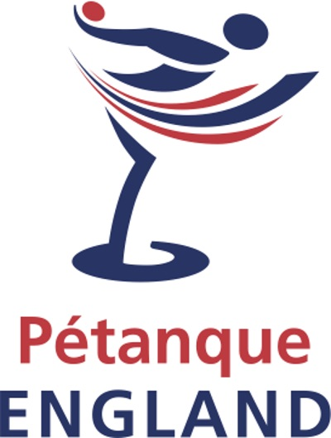
I agree to abide by the club code of conduct.
I do / do not want my email address and telephone numbers to be
shared with other club members.

Signed ____________________________________ Date_____________________________

Parley Pétanque Club | £35.00 p.a.
Junior Membership | Free
Payable to Parley Pétanque Club.
Payment by BACS preferred. Sort Code 30-97-21 Account Number 25370860
The club plays in various leagues and competitions if you would be interested in joining them please tick as appropriate:
Southern Counties |  | Other Competitions
New Forest Pétanque League |  | National Competitions

